**LAPTOP REQUEST CATALOG ITEM**

**Team ID : NM2025TMID19888**

**Team Size : 4**

**Team Leader : THIRUMALAI V**

**Team member : SARAVANAN J**

**Team member : SARATHI S**

**Team member : POOVARASAN M**

**PROBLEM STATEMENT**

Employees in the organization need a quick and efficient way to request laptops for work. The current process is manual and prone to delays, with no dynamic form behaviour to guide users or ensure accurate data collection. To address this, a Service Catalog item needs to be created, allowing users to easily request a laptop, with dynamic fields, clear instructions, and additional functionality like resetting the form if needed. The solution should also ensure all changes are tracked for governance and deployment.

**OBJECTIVES**

* Create a Service Catalog Item for laptop requests in ServiceNow.
* Implement dynamic form behaviour (e.g., showing fields based on user selections such as laptop type, accessories, urgency).
* Provide clear instructions and guided form input to reduce errors.
* Add a reset functionality to allow users to start fresh if they make mistakes.
* Enable tracking and auditing of all changes for governance and deployment readiness.
* Streamline the laptop request process, reducing manual delays and ensuring accurate data collection.

**SKILLS**

* ServiceNow Administration – Creating and managing catalog items, variables, and record producers.
* Catalog Client Scripts & UI Policies – Implementing dynamic form behaviour (show/hide, mandatory fields).
* Workflow & Flow Designer – Automating laptop request approvals and fulfilment processes.
* Change Management & Governance – Ensuring all updates are properly tracked and auditable.
* Form Design & User Experience – Building intuitive, user-friendly request forms.
* Project Management Basics – Organizing request workflows, monitoring progress, and ensuring timely delivery.

**TASK INITIATION**

**Milestone 1:** Update Set

**Activity 1:** Create local update sets

**Steps to Create local update sets in ServiceNow:**

1. Open ServiceNow platform.
2. In the instance on the left-hand navigation there will be an All option.
3. Click that and search for update set.
4. Select local update set under system update sets.

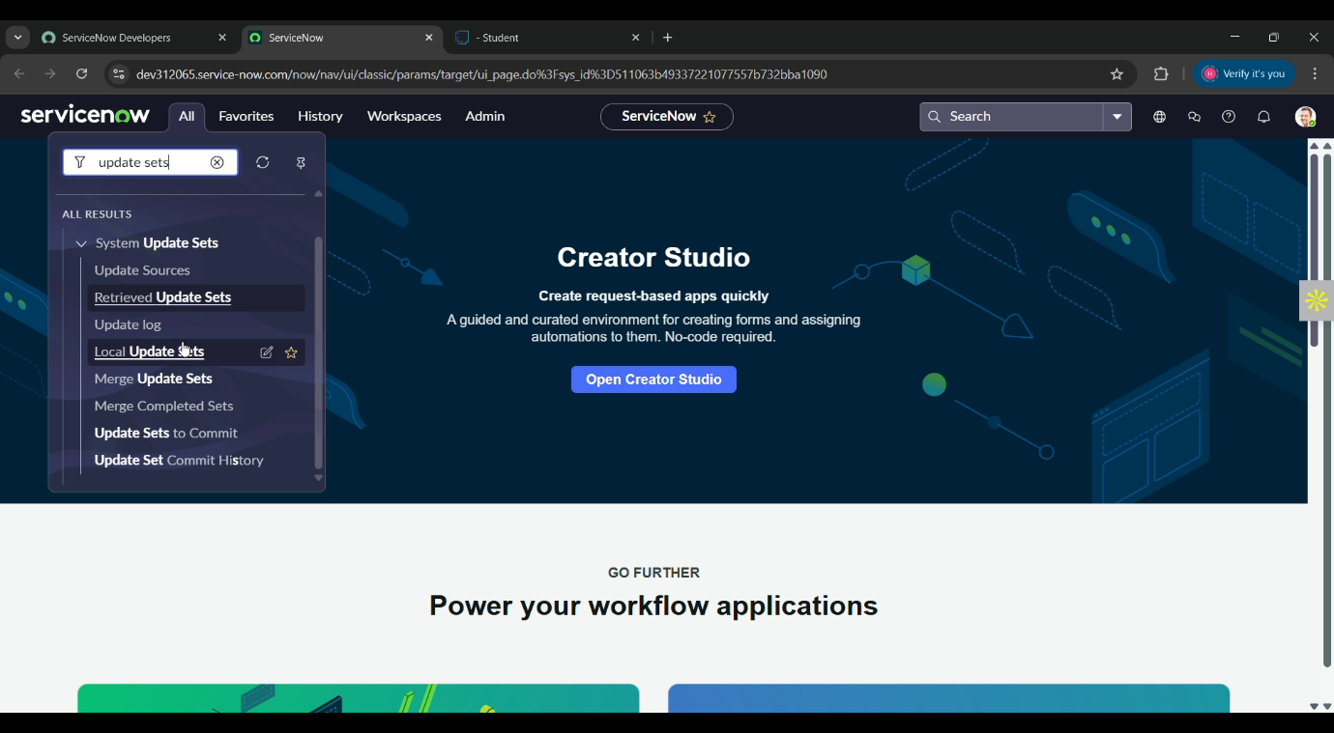**Fig 1**: update set

1. 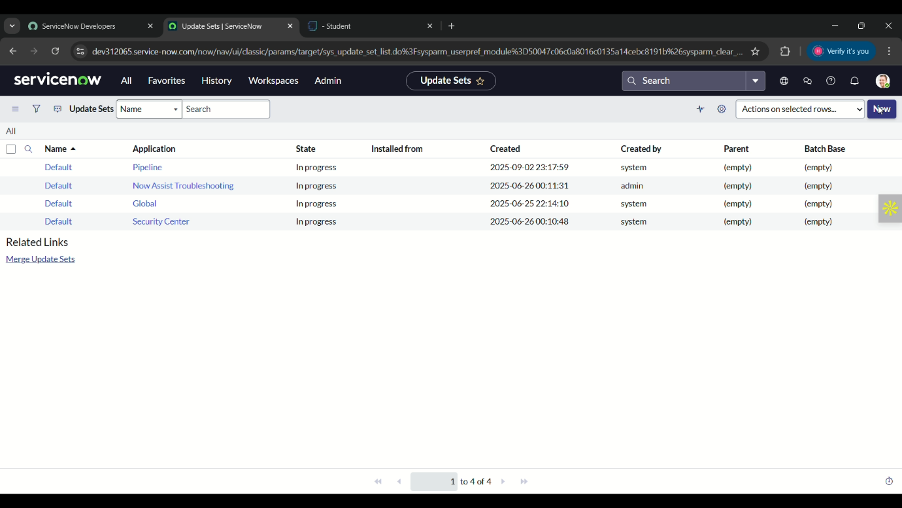Click new button in local update set module.

**Fig 2**: update set

1. Fill the following detail,

Name: Laptop request and save it.

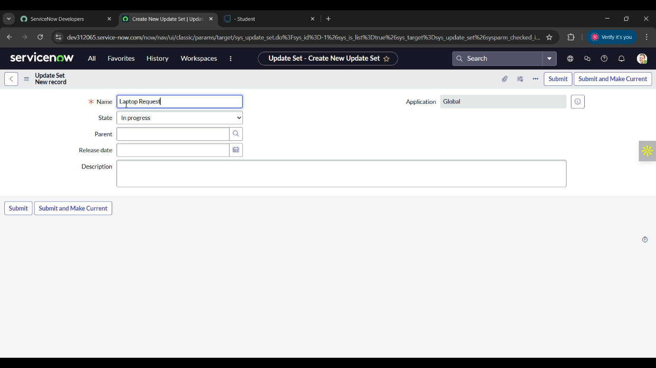**Fig 3:** update sets

**Milestone 2:** service catalog item

**Activity 1:** creating service catalog item

**Steps to create service catalog item in ServiceNow:**

1. Open ServiceNow.
2. Click on all and search for service catalog.
3. Under catalog definition, select the maintain items.
4. In maintain items module click on new to create new catalog item.
5. Fill the following details,

Name: laptop request

Catalog: service catalog

Category: hardware

1. In the short description mention – use this item to request a new laptop and save it.

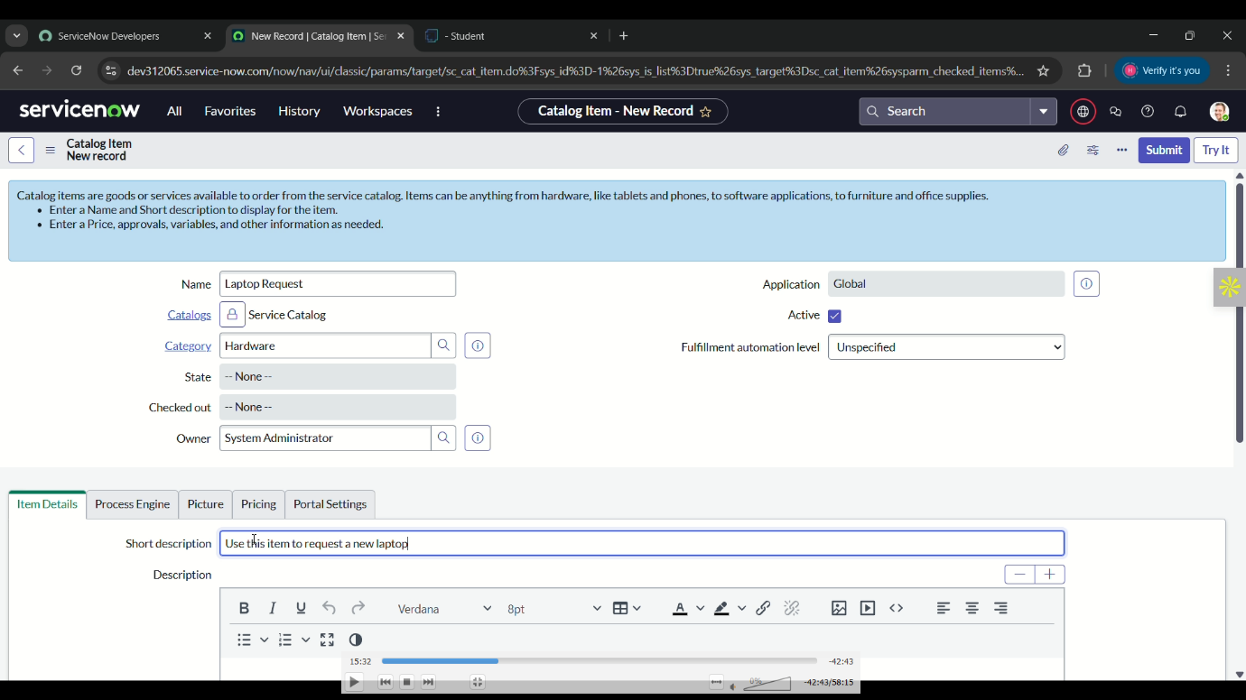**Fig 4:** service catalog item

**Milestone 2:** service catalog item

**Activity 2:** add variables

**Steps to add variables in service catalog item:**

1. Open ServiceNow
2. After saving the service catalog item, scroll down and click on variable
3. On variables, we are going to add 4 variables in it they are,

Variable 1: Laptop Model

Type: Single line text

Name: laptop_model

Order: 100

Variable 2: Justification

Type: Multi line text

Name: justification

Order: 200

Variable 3: Additional Accessories

Type: Checkbox

Name: additional_accessories

Order: 300

Variable 4: Accessories Details

Type: Multi line text

Name: accessories_details

Order: 400

1. 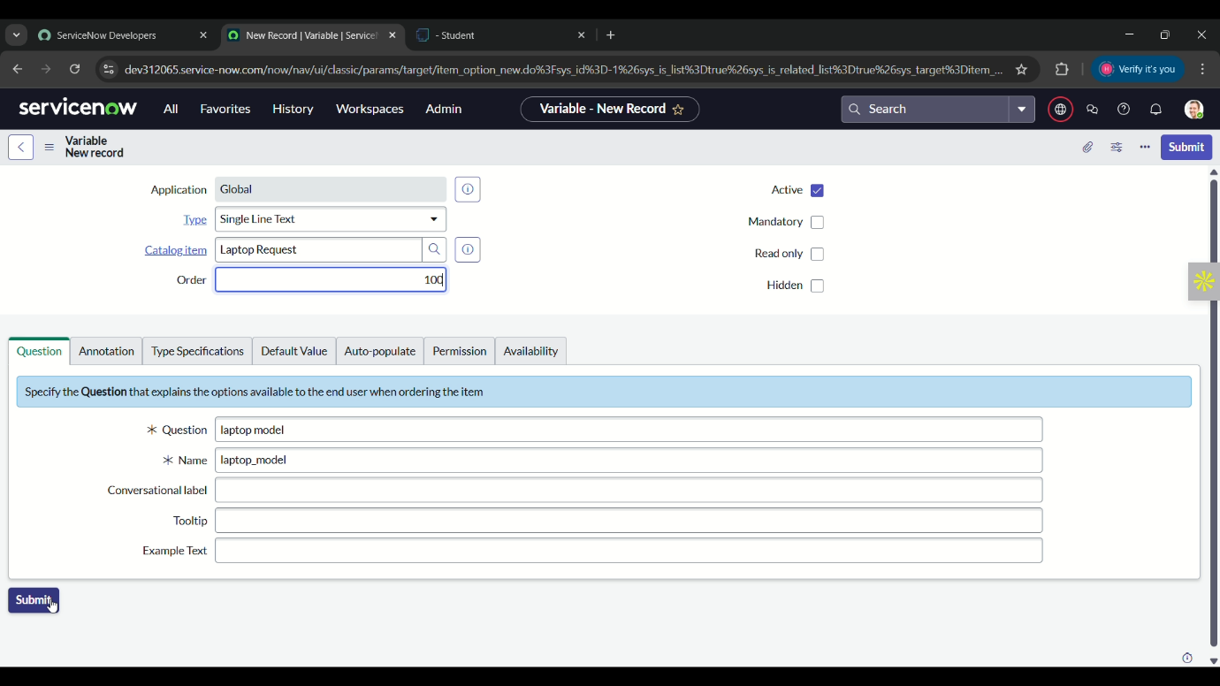After filling the details, save it.

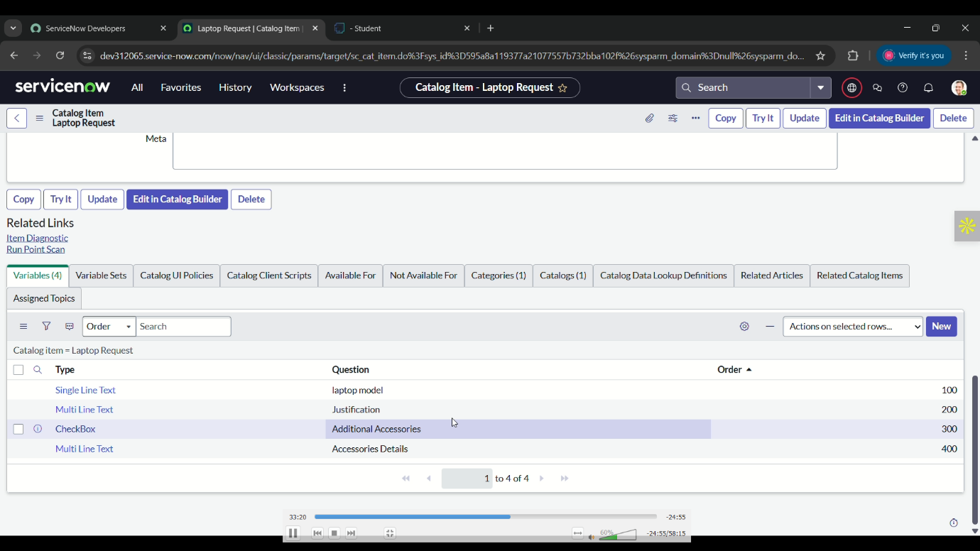**Fig 5:** add variables

**Fig 6:** add variables

**Milestone 3:** UI policy

**Activity 1:** create catalog Ui policy

**Steps to create a catalog Ui policy in ServiceNow:**

1. Open ServiceNow.
2. Repeat the step we did in the 2nd milestone’s 1st activity.
3. Click on all and search for service catalog.
4. Select maintain items under catalog definition, click on new.
5. Search laptop request to get the catalog Ui policies.
6. 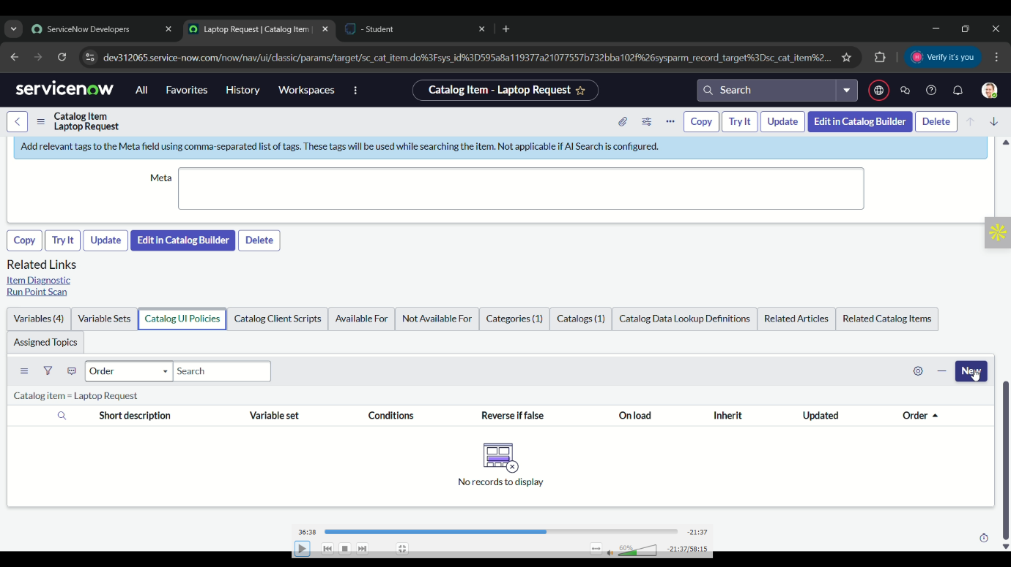Scroll down and click on catalog Ui policies.

**Fig 7:** create catalog Ui policies

1. On catalog Ui policies, click on new.
2. Fill the details,

short description as: show accessories detail.

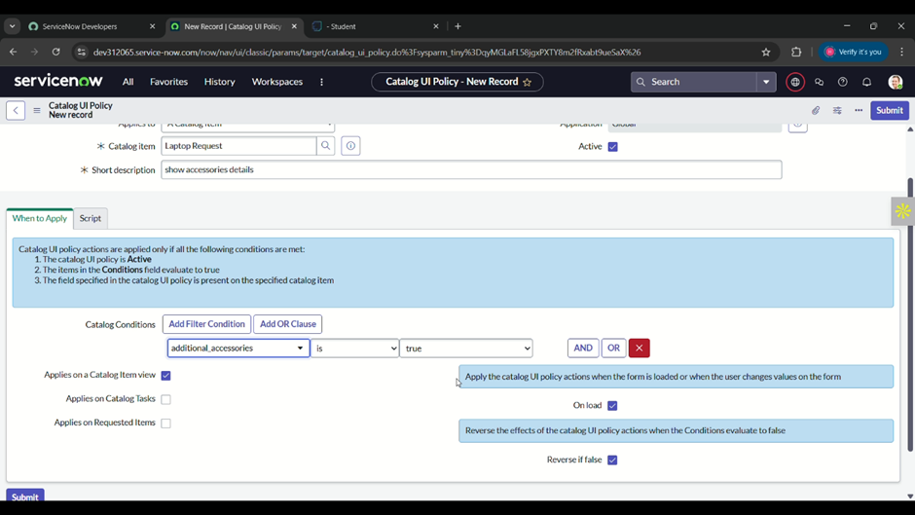Set the Catalog Condition as: field: additional_ accessories, operator: is, value: true and save it.

**Fig 8:** create catalog Ui policies

1. Scroll down, select catalog Ui action and click on new button.
2. Select variable name as: accessories_details,

Order as: 100,

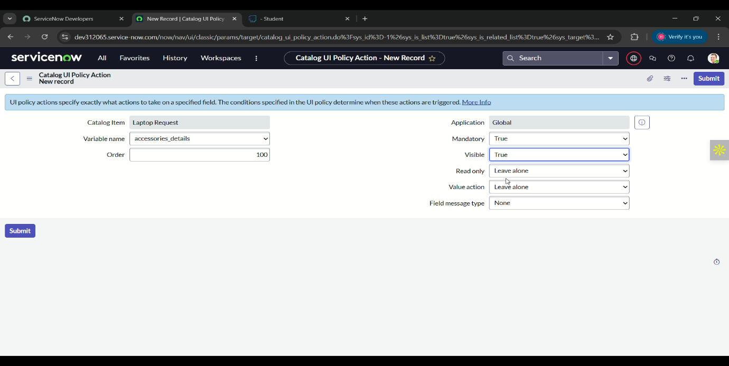Mandatory as: true. Visible as: true and save it.

**Fig 9:** create catalog Ui policies

**Milestone 4:** Ui action

**Activity 1:** create Ui action

**Steps to create Ui action in ServiceNow:**

1. Open ServiceNow.
2. Click all and search for Ui action.
3. Select Ui actions under system definition.

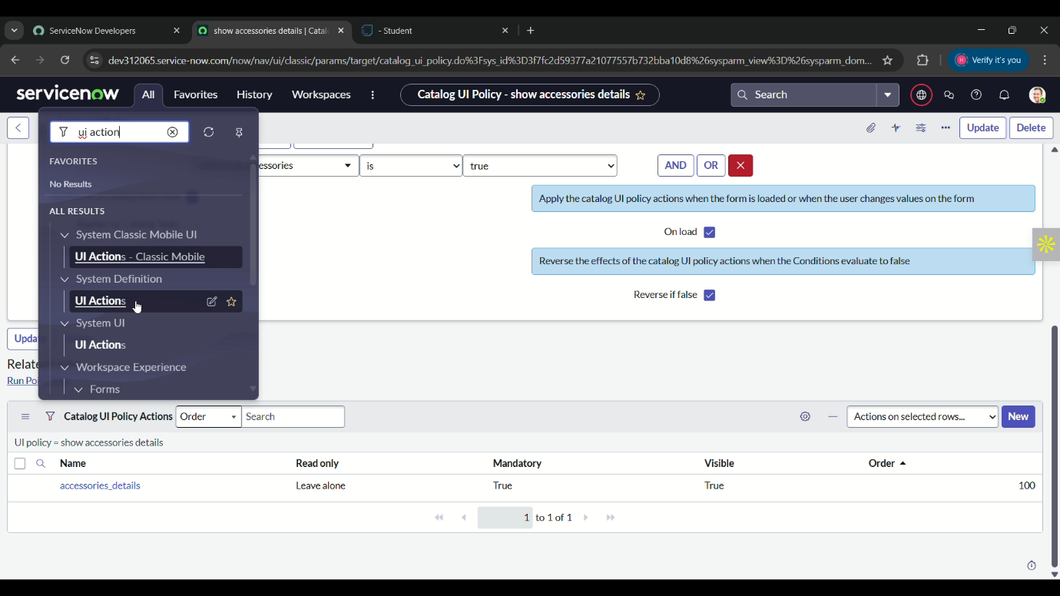**Fig 10:** create Ui action

1. In the Ui actions module, select the new button.
2. Fill the details,

Table: shopping cart(sc_cart)

Order:100

Action name: Reset form

Client: checked

Script:

function resetForm() {

g_form.clearForm(); // Clears all fields in the form

alert ("The form has been reset.");

}

**Fig 11:** create Ui action

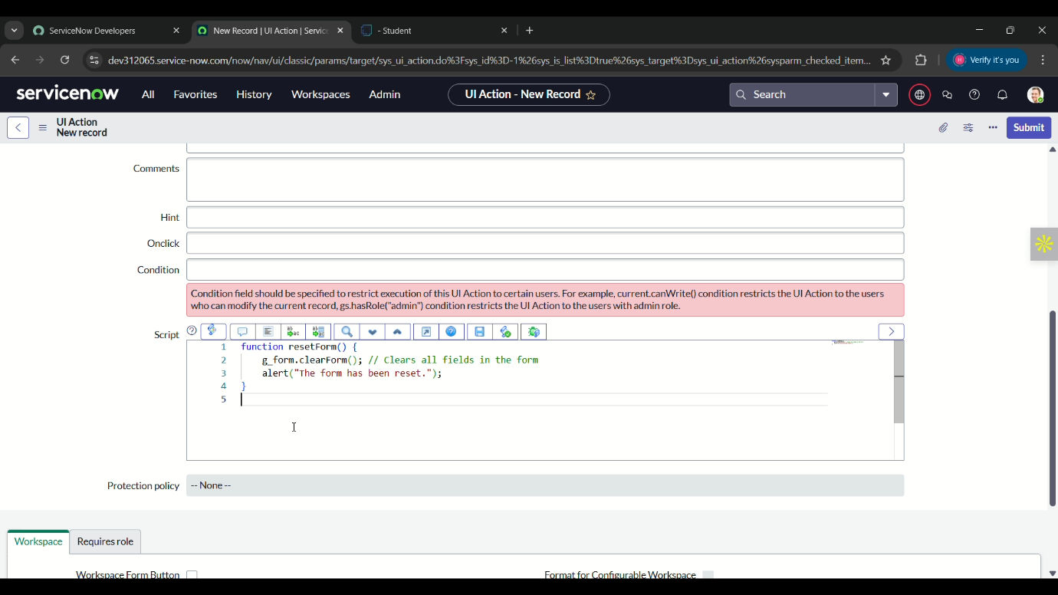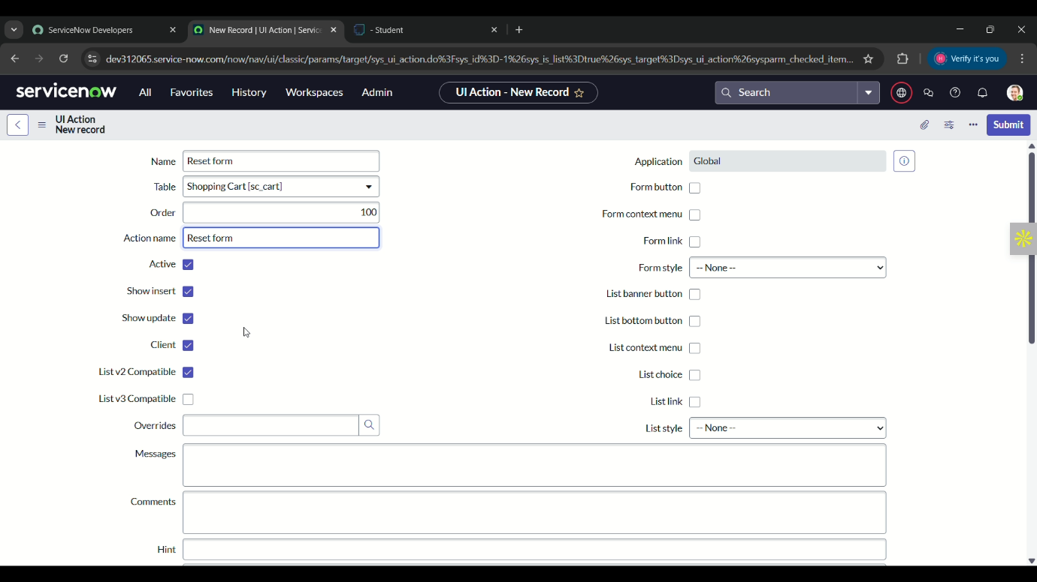

**Fig 12:** create Ui action

1. Click on save.

**Milestone 5:** Export update set

**Activity 1:** Exporting changes to another instances

**Steps to exporting changes to another instances:**

1. Open ServiceNow.
2. Click all and search for update sets.
3. Select local update sets.

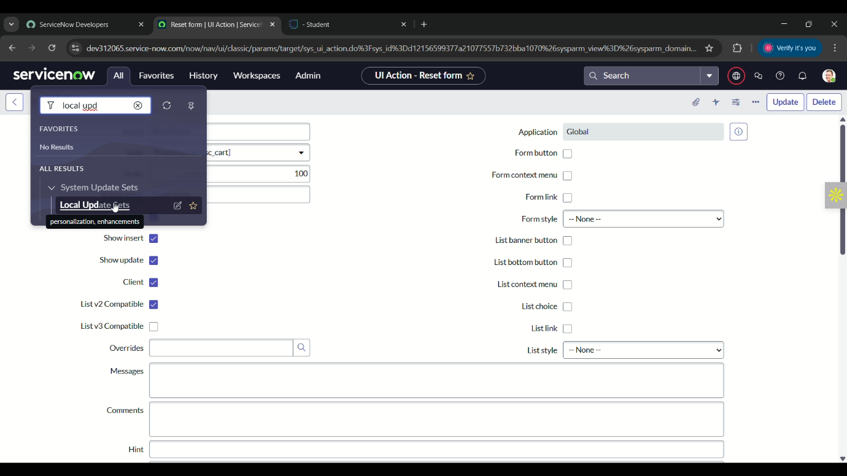**Fig 13:** export update set

1. Click on laptop request, on that set the state from in-progress to complete.
2. Save it.
3. In the bottom there will appear an Export to XML link.
4. Click that link a file will be downloaded automatically.

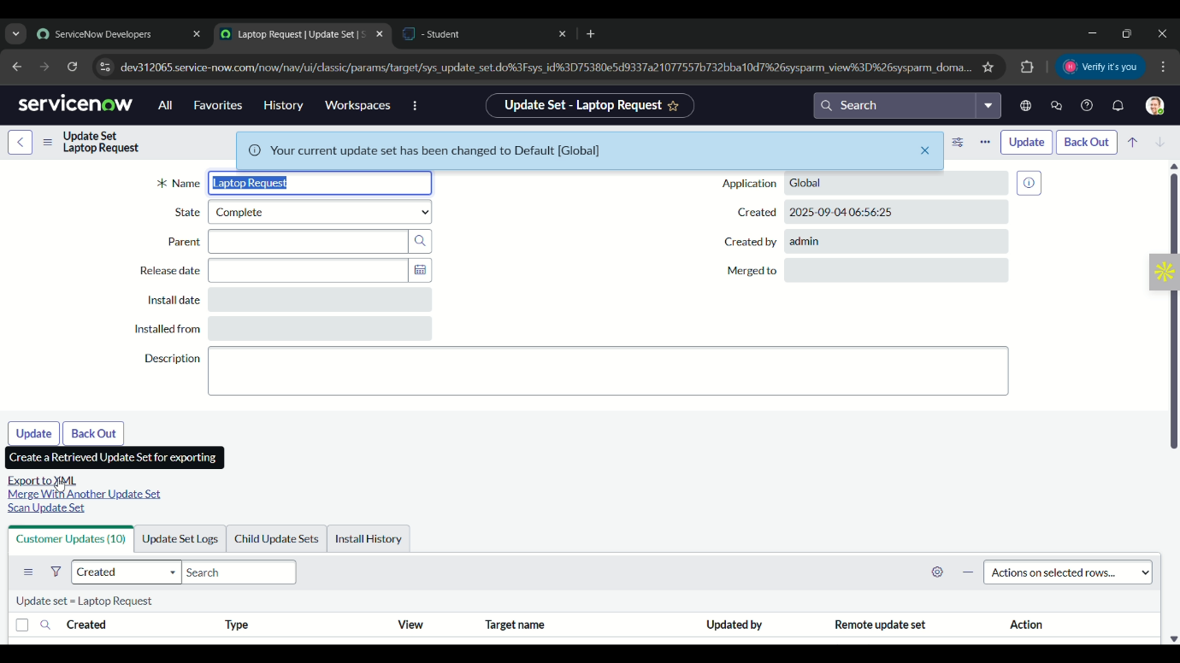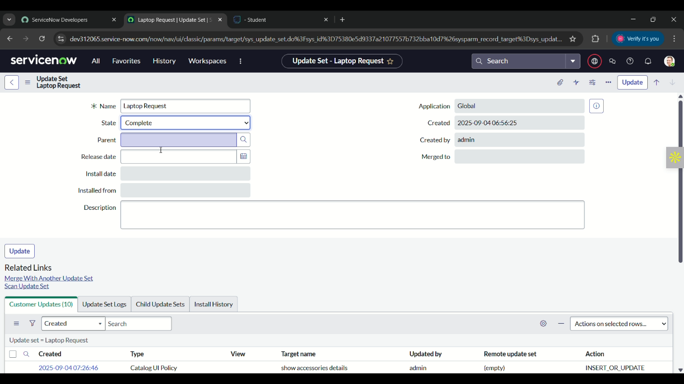**Fig 14:** export update set

**Fig 15:** export updates set

**Milestone 6:** login to another instance

**Activity 1:** Retrieving the update set

**Steps to retrieving the update set in ServiceNow:**

1. Open another team member’s ServiceNow instance.
2. Click on all and search for update sets.
3. 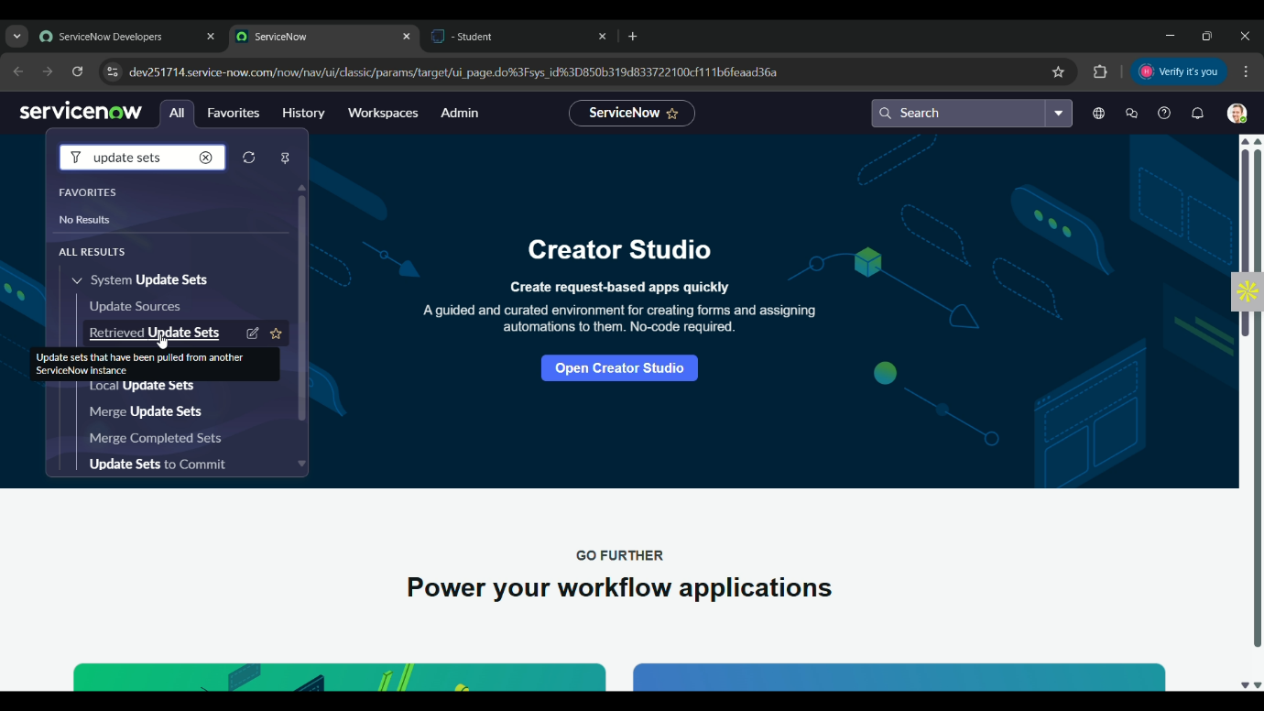Under the system update, select retrieved update set.

**Fig 16:** retrieving update set

1. Click on import update set from xml.

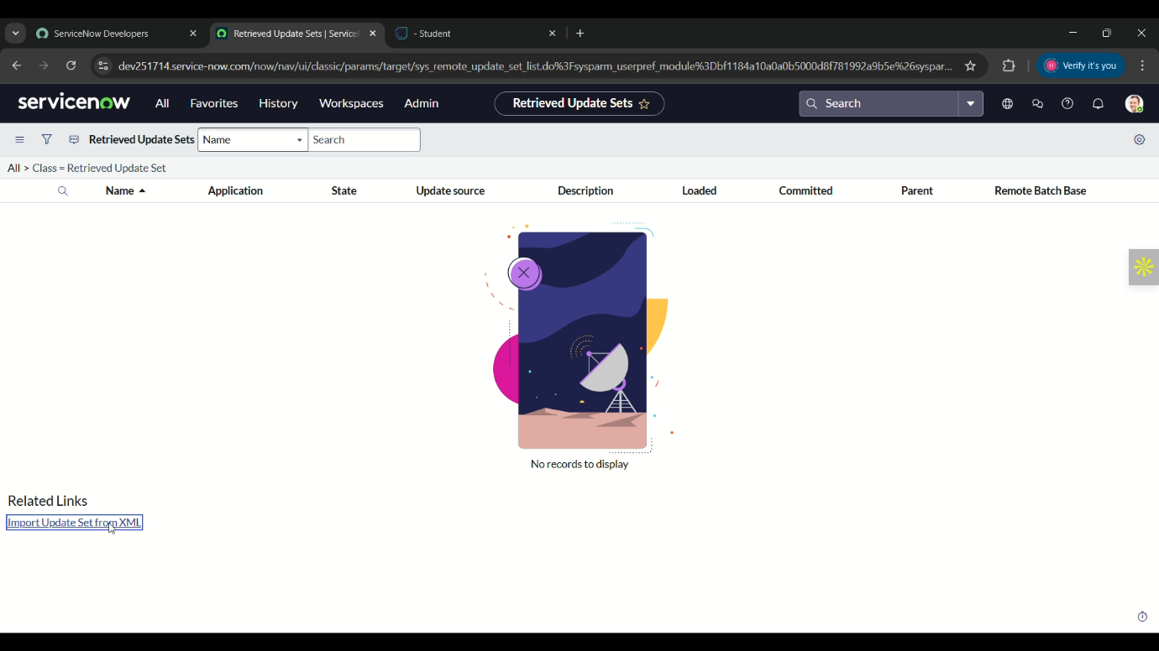

**Fig 17:** retrieving update set

1. 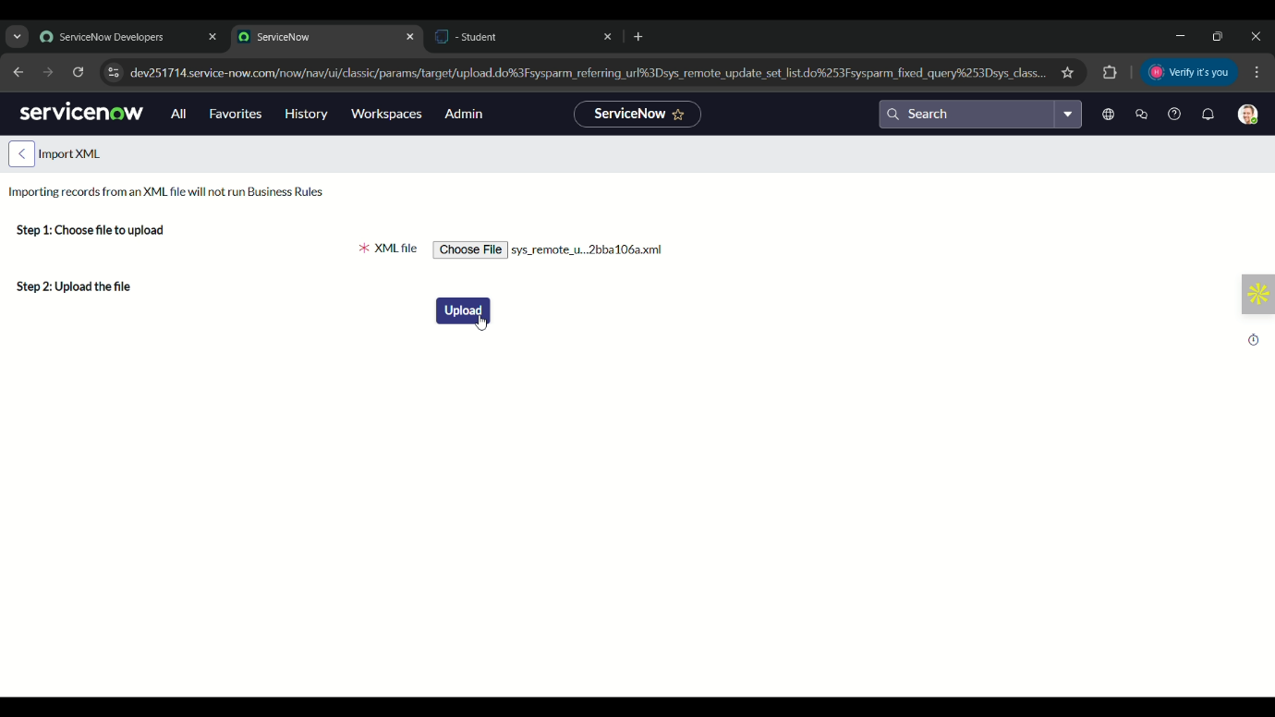Choose the downloaded file and upload it.

**Fig 18:** retrieving update set

1. Click the laptop request in retrieved update set.
2. 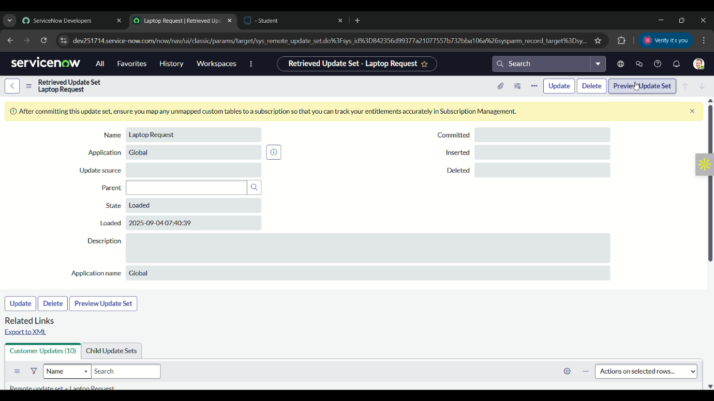Click the preview update set.

**Fig 19:** retrieving update set

1. 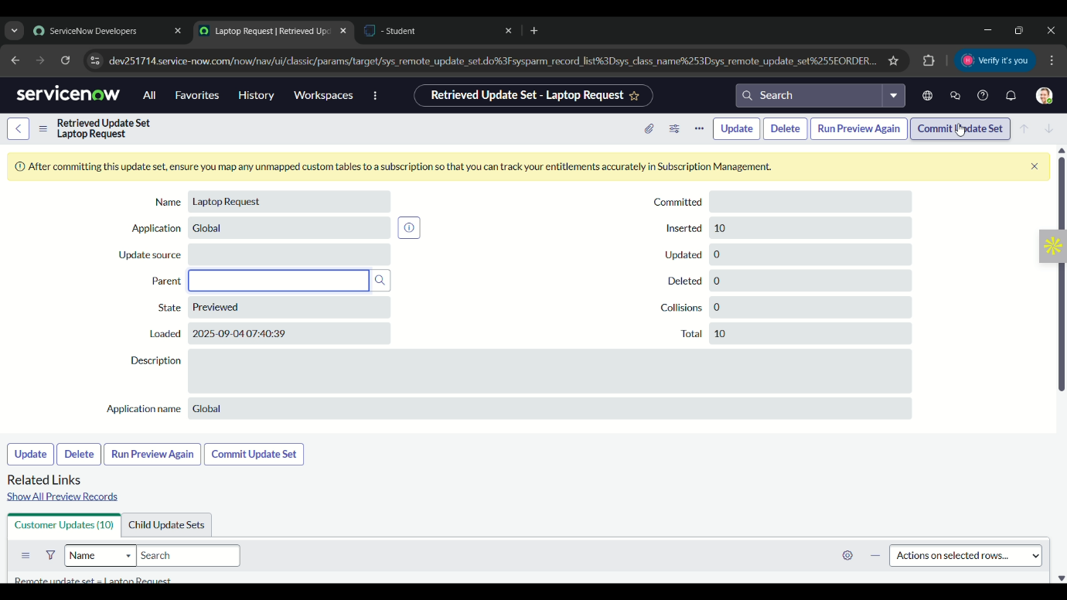After that click on commit update set.

**Fig 20:** retrieving update set

**Milestone 7:** Testing

**Activity 1:** Test catalog item

**Steps to test catalog item in ServiceNow:**

1. Open instance in ServiceNow.
2. Click all and search for catalog.
3. Select the catalog under service catalog.
4. On that module, select Hardware category.
5. Scroll down and select Laptop Request.
6. Here it will only show three variables

(laptop model, justification, additional accessories)

1. As per the instructions, when we click on the additional accessories checkbox then only the additional details will appear.

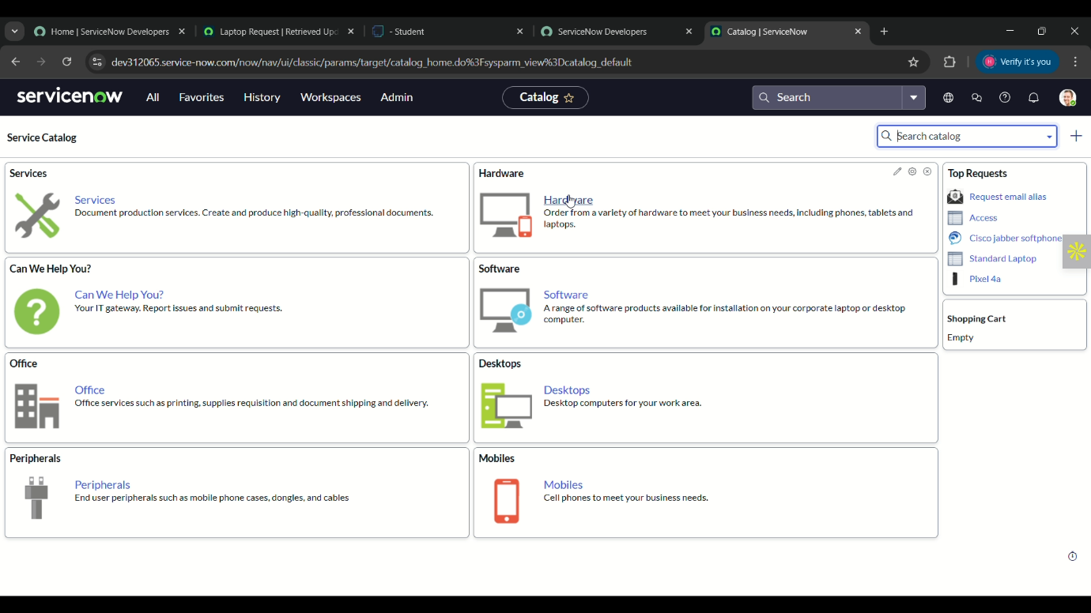**Fig 21:** test catalog item

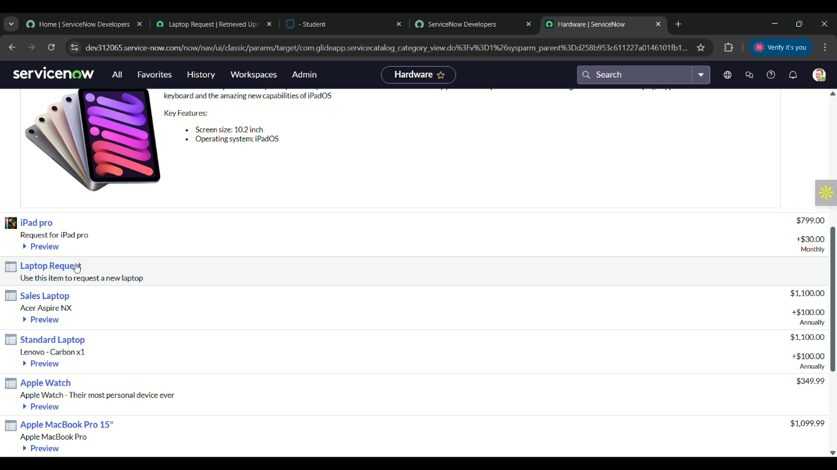

**Fig 22:** test catalog item

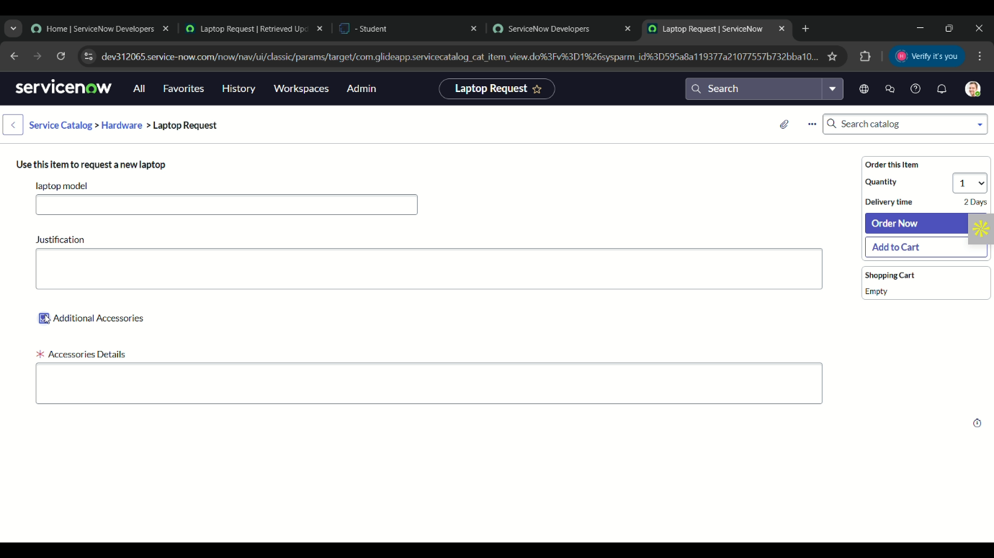**Fig 23:** test catalog item

1. Here the result fulfils our requirements.

**CONCLUSION:**

 The Laptop Request Catalog Item project successfully streamlines the process of requesting laptops within the organization by leveraging ServiceNow's Service Catalog capabilities. Through the implementation of a dynamic catalog item, the project ensures that users have an intuitive and user-friendly interface, reducing errors and improving efficiency. This project demonstrates how ServiceNow can be used to replace manual, error-prone processes with automated, efficient, and user-centric solutions. It not only improves service delivery but also enhances employee satisfaction by providing a modern and streamlined request experience.